JANUARY 10, 2024

E-TECH WEBSITE USING DJANGO
Software Design Description Document
Version: 1.0

Revision History

Date | Description | Author | Comments
10-01-2024 | <Version 1> | Muhammad Abbas | <First Revision>
 |  | Ayaz khan

Document Approval
The following Software Requirements Specification has been accepted and approved by the following:

Signature | Printed Name | Title | Date
 | Dr. | Supervisor, DIT | <date>

Table of Contents
- INTRODUCTION 1
  - Purpose
. 1
  - Scope 1
  - Overview 1
  - Reference Material 1
  - Definitions and Acronyms 2
- SYSTEM OVERVIEW 2
- SYSTEM ARCHITECTURE 4
  - Architectural Design 4
  - Decomposition Description 4
  - Design Rationale 4
- DATA DESIGN 12
  - Data Description 12
  - Data Dictionary 12
- COMPONENT DESIGN 13
- HUMAN INTERFACE DESIGN 13
  - Overview of User Interface 14
  - Screen Images 14
  - Screen Objects and Actions 14
- REQUIREMENTS MATRIX 15
- APPENDICES Error! Bookmark not defined.

INTRODUCTION

Purpose

The purpose of this software requirement specification is to provide a clear, documented model of the requirements for the online shopping system. This document serves to provide top level use cases for a web customer making purchases online. The system includes the client subsystem as well the seller subsystem.
The online shopping system provides a platform for conducting sales of a wide variety of goods across the globe. It is implemented as an internet based enterprise and has a vast inventory of products from books, houseware, electronics, groceries and much more.
Sellers use this system to easily expand their service to a more global platform. This guarantees better flexibility, larger audience and an improved market.
The appeal of online shopping systems experienced a large boost in the last decade because the customers can browse easily through various options, brands and price ranges with very little hassle. The ability to reap its benefits from the comfort of one’s own home has only bolstered its claim as one of the biggest enterprises that dominates the internet.

Scope

The online shopping system provides a platform for conducting sales of a wide variety of goods and provides a way of bringing sellers and customers on an online platform to conduct transactions in a secure manner across the globe. It is implemented as an online enterprise. This system provides an avenue for customers to shop from a wide variety of products online. It also provides sellers a platform where they can upload their listing to the system for customers to view and purchase. The biggest advantages of the service is the comfort it brings with remote usage. The ability to compare various price ranges, brands and even customer reviews and experiences provides for a more honest/depthful understanding of the product. It also provides a platform for retailers and sellers to reach a global audience.

1

Fitted with recommendation models to analyze customer interests, previous purchases and ratings can help recommend other products that the customer may like. This model is essential to increase visibility of useful products to the customer but also to boost the service’s revenue. The service also has a large database that stores customer data and history. Another important benefit provided by the service is the reviews section. The reviews section offers transparency around product performance and user experience. Not only do items have ratings given to it by users, but also detailed user reviews with an option to attach pictures of the product. This feature boosts customer trust and creates a community of customers who can engage with each other and help one another select the right products. A key feature is secure money transaction along with guaranteed and time bound product delivery.
Increasing sales is of the highest priority to the online shopping system. Turnover can increase only with an increase in sales. Various strategies need to be tested to find suitable growth strategies for the business. Minimizing management costs, customer loyalty and retention and customer satisfaction are essential corporate goals that are important to boost sales. A huge part of the business strategy is using the internet and its various resources to its advantage from technological innovation, marketing strategy and business model. Continuous and adaptive research and development with a focus on logistics is essential for business growth. Besides M&A, investments and strategic partnerships, another way to expand business is to invest in emerging markets and new businesses. The vision of the online shopping system is to be able to provide a smooth and user friendly platform for customers to select from a wide range of products conveniently and to cater to the needs of both customers and sellers.

Overview

The rest of this SDD document describes the various system architectures, datadesign, and interfaces of system.
.

Reference Material

There are many reference materials you can use to build an e-commerce website, depending on your specific needs and goals. Here are a few general categories to get you started:
https://help.shopify.com/en/manual/intro-to-shopify https://woo.com/documentation/woocommerce/
.

Definitions and Acronyms

E-commerce, or electronic commerce, refers to the buying and selling of goods or services online. It has revolutionized the way we shop, offering convenience, variety, and competitive prices. To navigate the world of e-commerce, understanding key terms and acronyms is crucial. Here's a helpful guide:


.

SYSTEM OVERVIEW
A system overview for an e-commerce website in the context of Software Design and Development (SDD) involves understanding the key components and interactions within the system. Below is a high-level system overview for an e- commerce website using Django as the web framework:

- User Interface (UI).
- Authentication and Authorization
- Product Management
- Shopping Cart and Checkout
- Order Processing
- Payment Gateway Integration
- Security
- Database
- Backend Logic
- Frontend and Backend Communication
- Scalability and Performance
- Logging and Monitoring
- Testing:
- Deployment
- Documentation

- ​

.

SYSTEM ARCHITECTURE

Architectural Design
Deployment diagram is showing an architecture of Ecommernce website is
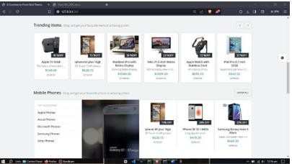

Decomposition Description
Decomposition in the context of software architecture refers to breaking down a complex system into smaller, more manageable components. For an e-commerce website, decomposition involves identifying and describing the various modules or subsystems that collectively make up the entire application. Below is a decomposition description for an e-commerce website.

Design Rationale
The design rationale for an e-commerce website encompasses the underlying principles, decisions, and considerations that guide the architectural and design choices made during the development process. Below are key design rationales for various aspects of an e-commerce website.

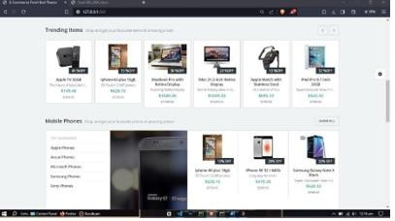
3.2.3Use-case Diagram
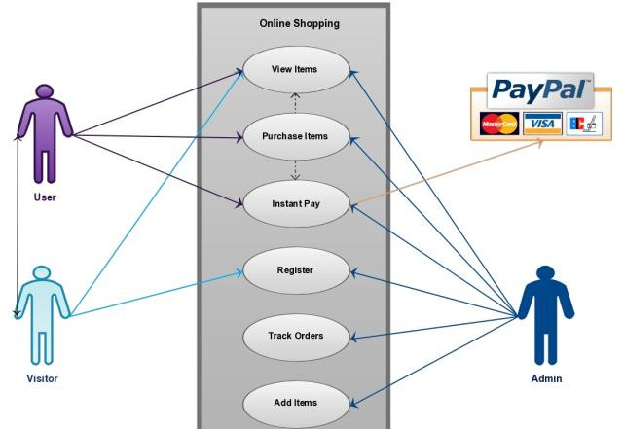
3.2.2 ER Diagram

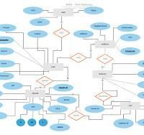
3.2.3 Activity Diagram
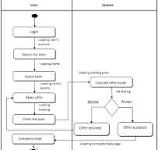
3.2.3.2 Login User
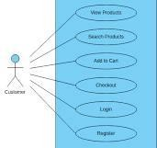
3.2.3.4 View Result by User

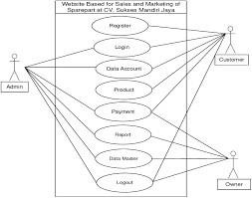
3.2.3.4 view Result by user
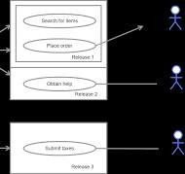
3.2.3.5 View Answer Question by user
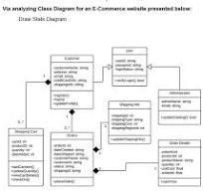
Sequence Diagram for Login User:
+ + + + + +

| User | | Web Browser | | Server |

+ + + + + +

| | |

| Request Login Page | |

| >| |

| | |

| | |

| | Render Login Page |  | | |  |  | |
|< | | |  |  |  | |
| | | |  |  | |
| | Submit Credentials | | |  |  |  | |
| | >| |  |  |  | |
| | | |  |  | |

| | | | Authenticate User |  | |
| | | |  |  |  | >|
| | | |  | |
| | | |  | |
| | | | Validate |  | |
| | | | Credentials |  |  | |
| | |< |  |  |  | |
| | | |  | |
| | | |  | |
| | | | Send Login Response |  |  |  | |
| | | | >|

| | | |  | |
| | | |  | |
| | | | Render |  | |

| | User Dashboard |

| |< |

Sequence diagram for login Register:
+ + + + + +

| User | | Web Browser | | Server |

+ + + + + +

| | |

| Request Login Page | |

| >| |

| | |

| | |

| Render Login Page | |

|< | |

| | |

| Submit Credentials | |

| >| |

| | |

| | Authenticate User |

| | >|

| | | |  | |
| | | |  | |
| | | | Validate |  | |
| | | | Credentials |  |  | |
| | |< |  |  |  | |
| | | |  | |
| | | |  | |
| | | | Send Login Response |
| | | | >|
| | | | |
|
Sequence diagram for View user by admin:
+ + + + + +

| Admin | | Web Browser | | Server |

+ + + + + +

| | |
| | Request Admin |  | | |  |  |  |  | |
| | Dashboard | | |  |  | |
| |  | >|
| | | |  |  | |
| | | |  |  | |
| | Render Admin |  | | |  |  |  |  | |
| | Dashboard | |

|

|

|< |  | | |  | |
| | | |  | |
| | | |  | |
| | Select User to | | |  | |
| | View Details | | |  | |
| |  | >| |  | |
| | | |  | |
| | | |  | |

| | Fetch User Details |

| | >|

| | |

| | |

| | Send User Details |

| | for Rendering |

| | >|

| | |

| | |

| | | | Render User Details |
| | | | in Admin Dashboard |
| | |< | |
| | | | |

DATA DESIGN

Data Description
1. User Entity:

- UserID (Primary Key): Unique identifier for each user.

Username: User's chosen username for authentication.
- Password (encrypted): Encrypted password for user authentication.

Email: User's email address for communication.
- FirstName: User's first name.
- LastName: User's last name.

Address: User's residential or shipping address.
- PhoneNumber: User's contact phone number.
- UserType: Indicates whether the user is a regular customer, an admin, or another user type.
RegistrationDate:
- Date and time when the user registered on the website.

Product Entity:
- ProductID (Primary Key): Unique identifier for each product.
- Name: Name of the product.
- Description: Detailed description of the product.
- Price: The price of the product.
- StockQuantity: Quantity of the product available in stock.
- CategoryID (Foreign Key): Relates to the Category entity to categorize the product.
- SupplierID (Foreign Key): Relates to the Supplier entity to identify the product's supplier.
- CreationDate: Date and time when the product was added to the system.
3. Category Entity:
- CategoryID (Primary Key): Unique identifier for each product category.
- CategoryName: Name of the product category.

4. Supplier Entity:
- SupplierID (Primary Key): Unique identifier for each supplier.
- SupplierName: Name of the supplier company.
- ContactPerson: Person to contact at the supplier company.
- Email: Email address of the supplier company.
- PhoneNumber: Contact phone number of the supplier company.
- Address: Address of the supplier company.
Relationships:
- User-Order Relationship: Each User can place multiple Orders (One-to-Many relationship).
- Order-OrderItem Relationship: Each Order can have multiple OrderItems (One-to-Many relationship).
OrderItem-Product Relationship:
- Each OrderItem is associated with one Product (Many-to- One relationship).
Product-Category Relationship:
- Each Product belongs to one Category (Many-to-One relationship).
Product-Supplier Relationship:
- Each Product is supplied by one Supplier (Many-to-One relationship).

Data Dictionary

A data dictionary provides a comprehensive description of the data elements (attributes or fields) in a database, including their names, data types, constraints, and other relevant information. Below is an example of a data dictionary for the entities mentioned in the data design of an e-commerce website:

COMPONENT DESIGN
The component design of an e-commerce website involves breaking down the system into modular and manageable components, each responsible for specific functionalities. Below is a high-level component design for an e-

commerce website:

HUMAN INTERFACE DESIGN

Overview of User Interface
The user interface (UI) of an e-commerce website is a critical component that directly impacts the user experience and can significantly influence the success of the platform. Below is an overview of the key aspects and elements commonly found in the user interface of an e-commerce website:.

Screen Images


Screen Objects and Actions

.

REQUIREMENTS MATRIX
A requirements matrix, also known as a traceability matrix, is a tool used to document and track the relationship between different components of a project, such as requirements, features, and test cases. For an e-commerce website, a requirements matrix may include the following elements.

